 | 
26th February to 01st March, 2024
Cyber-Physical Systems Design in the context of Industry 4.0
This course is created following the application (in 2022) to the Mobility Program for Higher Education Students and Staff funded by the Erasmus+ Program, under Key Action 1: Individual Mobility for Learning Purposes (KA131) - Blended Intensive Programs (BIP) and after approval by the Portuguese National Agency.
Scope
The main objective consists on providing, to the students, knowledge and solid foundations in the Cyber-Physical Systems Design, taking into account, mainly, the physical part of these systems. The target students are students from 1st cycle of superior studies, in Mechanical Engineering, or related domains, where the taught subjects may be of their own interest
Topics
This course is composed by five modules supervised by
Very skilled Professors in the respective domains:

In the Module "Modelling and Simulation of Mechanical Behavior of Cyber-Physical Systems" – supervised by Prof. Pierluigi Rea, from University of Cagliari, Italy - the student must be able to simulate the behavior of a mechanical system (controller and physical part) and use simulation techniques and software such as Matlab, Autosim-200, or other similar;

In the module "Assessment of Risk of Cyber-Physical Systems", supervised by Prof. Anna Burduk, from Wrocław University of Science and Technology, Poland - student must be able for assess and prevent risk during operation of Cyber-Physical Systems;

In the module "Robotic Applications of Cyber-Physical Systems" - supervised by Prof. Erika Ottaviano, from University of Cassino and Southern Latium, Italy - student must be able of understanding the functioning and programming of robots in different practical situations; considering dedicated software tools such as Matlab.

In the module "Interconnectivity of Cyber-Physical Systems"- supervised by Prof. Camelia Avram, from Technical University of Cluj-Napoca, Romania - student must be able for defining the architecture for the distributed controller and develop the corresponding controller program;

In the module "Smart Maintenance of Cyber-Physical Systems" - supervised by Prof. Katarzyna Antosz‬, from Rzeszów University of Technology, Poland - student must be able for consider, during design phase, aspects related with maintenance and provide some measures and calculations for being possible smart maintenance during life-cycle of the equipment.‬‬‬

Partners
Prof. José Machado: jmachado@dem.uminho.pt |   Prof. Erika Ottaviano: ottaviano@unicas.it
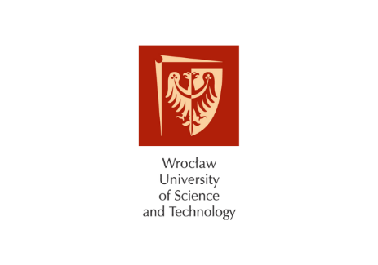  Prof. Anna Burduk: anna.burduk@pwr.edu.pl |   Prof. Camelia Avram: camelia.avram@aut.utcluj.ro
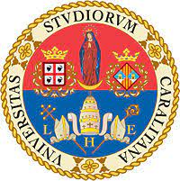  Prof. Pierluigi Rea: pierluigi.rea@unica.it |   Prof. Katarzyna Antosz: katarzyna.antosz@prz.edu.pl

Course Place
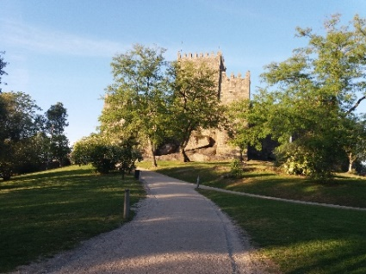

The Course will be held in from 26th February to 01st March 2024, at University of Minho, in Guimarães, a Portuguese world heritage city, 55 kilometers to the north of Porto.
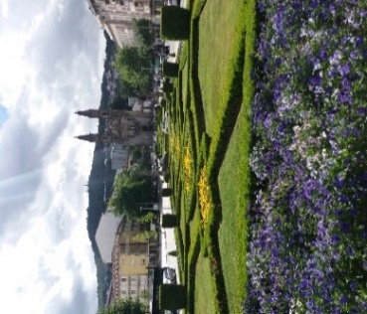



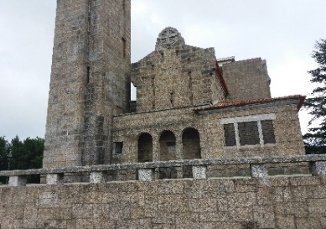
Contact
University of Minho, School of Engineering, Mechanical Engineering Department, Campus of Azurém
4800-058 GUIMARÃES, PORTUGAL
José Machado
Course Organizer: jmachado@dem.uminho.pt

